Semester 2 2021

ATAR course examination

Question/Answer booklet

**Year 11 ATAR COMPUTER SCIENCE AECSC**

Surname:

Other names:

WA student number (if known)

SIDE Teacher:

SIDE Student Coordinator:

**Supervisor’s declaration**

I declare that this examination paper has been completed by the student named above. The time and resource restrictions have been observed and the student has NOT accessed notes, texts, reference books, the internet, a computer, a calculator or a mobile phone unless otherwise specified. I understand that breaches of the examination rules could lead to an examination paper being cancelled or having an examination mark significantly lowered.

Supervisor’s name:

Signature: Date:

**Time allowed for this paper**

Reading time before commencing work: ten minutes

Working time: three hours

**Materials required/recommended for this paper**

***To be provided by the supervisor***

This Question/Answer booklet

***To be provided by the candidate***

Standard items: pens (blue/black preferred), pencils (including coloured), sharpener, correction fluid/tape, eraser, ruler, highlighters

Special items: up to three calculators, which do not have the capacity to create or store programmes or text, are permitted in this ATAR course examination, Mathomat and/or Mathaid and/or any system flowchart template

**Important note to candidates**

No other items may be taken into the examination room. It is **your** responsibility to ensure that you do not have unauthorised material. If you have any unauthorised material with you, hand it to the supervisor **before** reading any further.

**Structure of this paper**

|  |  |  |  |  |  |
| --- | --- | --- | --- | --- | --- |
| Section | Number of questions available | Number of questions to be answered | Suggested working time (minutes) | Marks available | Percentage of examination |
| Section One:  Short answer | 21 | 21 | 70 | 100 | 40 |
| Section Two:  Extended answer | 5 | 5 | 110 | 99 | 60 |
|  |  |  |  | **Total** | 100 |

**Instructions to candidates**

1. The rules for the conduct of Western Australian external examinations are detailed in the *Year 12 Information Handbook 2021*. Sitting this examination implies that you agree to abide by these rules.

2. Write your answers in the spaces provided in this Question/Answer Booklet. A blue or black ballpoint or ink pen should be used. Wherever appropriate, fully labelled diagrams, tables and examples should be used to illustrate and support your answers.

3. You must be careful to confine your responses to the specific questions asked and to follow any instructions that are specific to a particular question. Where no specific instructions are given, you should feel free to use a range of formats to express your knowledge and understandings.

4. Spare pages are included at the end of this booklet. They can be used for planning your responses and/or as additional space if required to continue an answer.

* Planning: If you use the spare pages for planning, indicate this clearly at the top of the page.
  + Continuing an answer: If you need to use the space to continue an answer, indicate in the original answer space where the answer is continued, i.e. give the page number. Fill in the number of the question(s) that you are continuing to answer at the top of the page.

**Section 1: Short Answer 40% (100 Marks)**

This section contains **21** questions. You must answer **all** questions. Write your answers in the spaces provided.

Spare pages are included at the end of this booklet. They can be used for planning your responses and/or as additional space if required to continue to answer.

* Planning: If you use the spare pages for planning, indicate this clearly at the top of the page.
* Continuing an answer: If you need to use the space to continue an answer, indicate in the original answer space where the answer is continued, i.e. give the page number. Fill in the number of the question that you are continuing to answer at the top of the page.

Suggested working time: 70 minutes.

**Question 1 (2 marks)**

Describe the purpose of a Level 0 Data Flow Diagram.

**Question 2 (3 marks)**

Explain one key difference between non-procedural languages and object-oriented languages.

**Question 3 (2 marks)**

Describe how a digital signature protects data.

**Question 4 (3 marks)**

Discuss the term ‘hierarchical structure of data’ referring to relational databases.

**Question 5 (2 marks)**

What is meant by the term atomicity in relation to databases?

**Question 6 (6 marks)**

Examine the following diagram

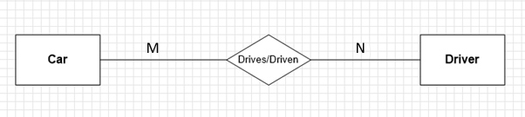

1. Explain why this ERD will cause issues within a database if it is left unresolved.

(3 marks)

1. Discuss how this ERD would be resolved. (3 marks)

**Question 7 (2 marks)**

Discuss how relationships are established in a Relational Database Management System. You may draw a diagram to assist.

**Question 8 (6 marks)**

This question relates to the following code snippet.

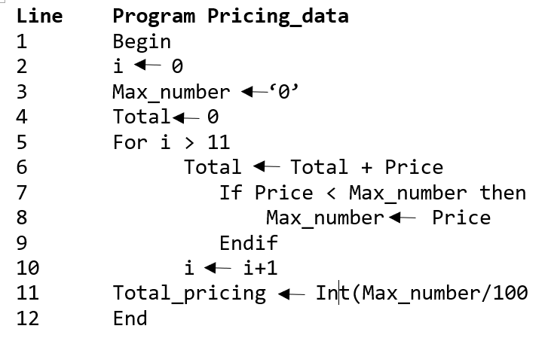

Using an example from the code, explain what happens when the following errors occur.

1. Run-time:

Example:

Explanation:

1. Logic:

Example:

Explanation:

**Question 9 (2 marks)**

In programming what is a syntax error?

**Question 10 (9 marks)**

Describe the purpose of the following and explain their impact on system performance:

1. Central Processing Unit:

1. Bus:

1. System clock:

**Question 11 (9 marks)**

Tick the boxes (there can be more than one) that are relevant to the following memory type

|  |  |  |  |
| --- | --- | --- | --- |
| **Description** | **ROM** | **RAM** | **Cache** |
| Stores the start-up process |  |  |  |
| Read-only |  |  |  |
| Stores frequently used instructions |  |  |  |
| Located on or beside CPU |  |  |  |
| Volatile |  |  |  |
| Read-write |  |  |  |
| Non-volatile |  |  |  |

**Question 12 (6 marks)**

What are the stages of the System Development Life Cycle (SDLC)?

**Question 13 (5 marks)**

Discuss the advantages and disadvantages of creating a computer network within a small to medium sized business.

**Question 14 (10 marks)**

A game is played as follows:

* Two dice are thrown one red and the other blue.
* If the dice are the same value – a score of 0 is recorded and the game ends
* If they are not the same value the score = score + red value – blue value. After this process, if the score is less than 0 then the score becomes 0 then the game ends.
* Otherwise the score is stored for the next round and the dice get thrown again.

1. Create a flowchart for the above program below. (7 marks)
2. Using this flowchart, complete the score column for the first roll in the table below. (3 marks)

|  |  |  |
| --- | --- | --- |
| **Red Dice** | **Blue Dice** | **Score** |
| 4 | 4 |  |
| 2 | 6 |  |
| 6 | 3 |  |

**Question 15 (5 marks)**

1. How many bits in 1 Kilobyte?
2. How many Kilobytes in 24,576 bits?
3. How many Kilobytes in 8,192 Bytes?
4. How many Kilobytes in 2 Megabytes?
5. How many bits in 2 Bytes?

**Question 16 (3 marks)**

Convert the following

1. 10110111 into Decimal: __________________________
2. 222 into binary: __________________________
3. Binary has 2 numbers, Decimal has 10 –   
   How many numbers does the Hexadecimal system have?

**Question 17 (12 marks)**

Consider the following code.

Complete the trace table that follows for the four Passengers inputs 150, 100, 50, -100

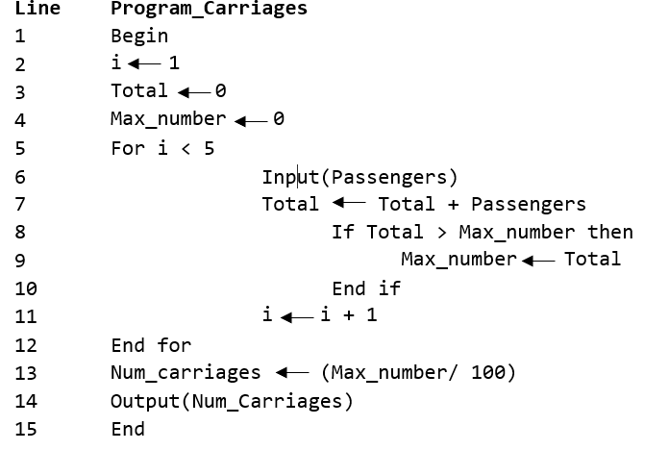

|  |  |  |  |  |  |  |  |
| --- | --- | --- | --- | --- | --- | --- | --- |
| **Line** | **i** | **i < 5** | **Passengers** | **Total** | **Max_number** | **Num_carriages** | **Output** |
|  |  |  |  |  |  |  |  |
|  |  |  |  |  |  |  |  |
|  |  |  |  |  |  |  |  |
|  |  |  |  |  |  |  |  |
|  |  |  |  |  |  |  |  |
|  |  |  |  |  |  |  |  |
|  |  |  |  |  |  |  |  |
|  |  |  |  |  |  |  |  |
|  |  |  |  |  |  |  |  |
|  |  |  |  |  |  |  |  |
|  |  |  |  |  |  |  |  |
|  |  |  |  |  |  |  |  |
|  |  |  |  |  |  |  |  |
|  |  |  |  |  |  |  |  |
|  |  |  |  |  |  |  |  |
|  |  |  |  |  |  |  |  |
|  |  |  |  |  |  |  |  |
|  |  |  |  |  |  |  |  |
|  |  |  |  |  |  |  |  |
|  |  |  |  |  |  |  |  |

**Question 18 (2 marks)**

Discuss the difference between a client/server network and peer to peer network.

**Question 19 (6 marks)**

Discuss the function of the following devices within a Wider Area Network or LAN.

Bridge:

Switch:

Router:

**Question 20 (3 marks)**

Referring to an example, discuss why a protocol is required within a network.

**Question 21 (2 marks)**

Identify an advantage and a disadvantage of using a star topology.

**End of Section One**

**Section Two: Extended answer 60% (99 Marks)**

This section has **five (5)** questions. Answer **all** questions. Write your answers in the spaces provided.

Spare pages are included at the end of this booklet. They can be used for planning your responses and/or as additional space if required to continue to answer.

* Planning: If you use the spare pages for planning, indicate this clearly at the top of the page.
* Continuing an answer: If you need to use the space to continue an answer, indicate in the original answer space where the answer is continued, i.e. give the page number. Fill in the number of the question that you are continuing to answer at the top of the page.

Suggested working time: 110 minutes.

Wesley runs a small bakery and coffee shop in his local suburb. Each day he has queues for his bread and beverages.

Currently his shop has been an accidental success and he is convinced that he needs a more professional system that will help the shop managers keep track of costs so he has hired a System Analyst and Developer. A number of larger business have also started buying from him directly. At present they do not place orders but Wesley can see that this is likely to change.

Wesley has been keeping track of his costs and revenue through a series of spreadsheets.

The Analyst hired has found the following.

* Customers place their order at the till. The till is programmed to differentiate between all order items. The till operator inputs their order and advises the customer how much is to be paid as calculated by the till.
* The customer pays.
* A bread/cake order is immediately handed to the customer by the till operator.
* If there is a beverage order, the receipt with the customer name is passed to the barista. They hang the receipt over the coffee machine and give this to the customer once they collect their beverages.
* Wesley will get a report at 4pm each day detailing how many baked goods and beverages were sold and will use this to estimate the supplies he needs.
* The daily takings from the till are emptied at 6pm and a print out detailing the number of each good sold is obtained and this information is transferred into Wesley’s spreadsheet.
* Wesley will contact his suppliers to place an order using an order pad. He places the order on a spike.
* The ingredients will be delivered the next day at 8am and Wesley attaches the order to the delivery slip.
* At the end of each month, Wesley receives an invoice from his suppliers. He checks each item against the delivery slips and orders and when his invoices are reconciled, he pays each supplier.

The following images are extracts from some of the worksheets Wesley uses currently.

Figure A

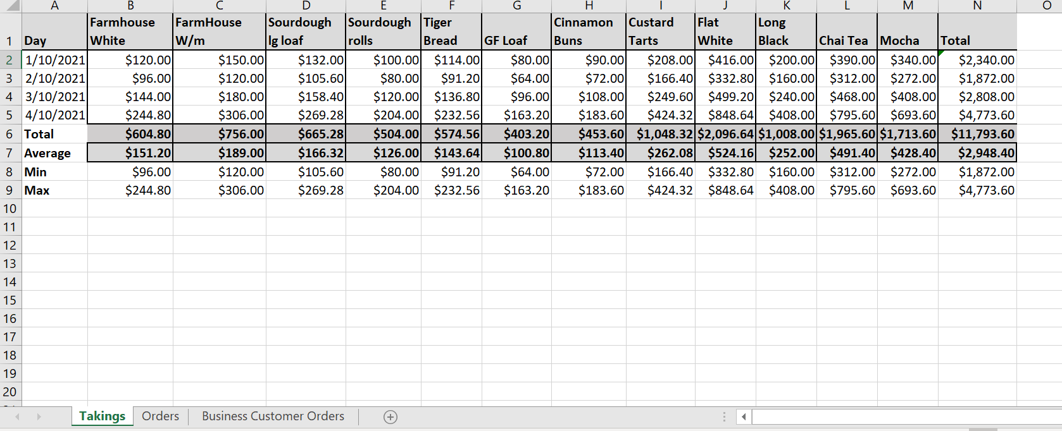

Figure B

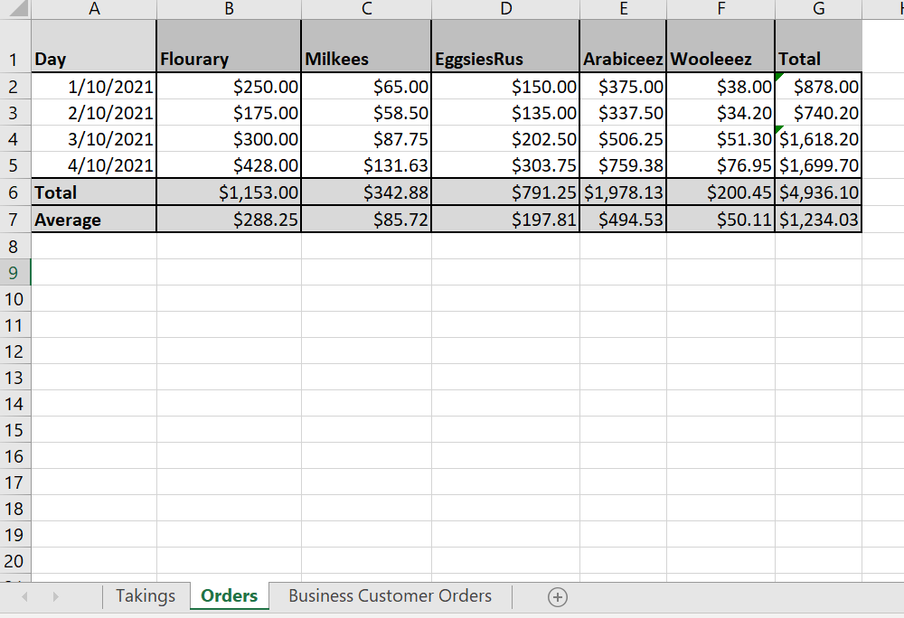

Figure C

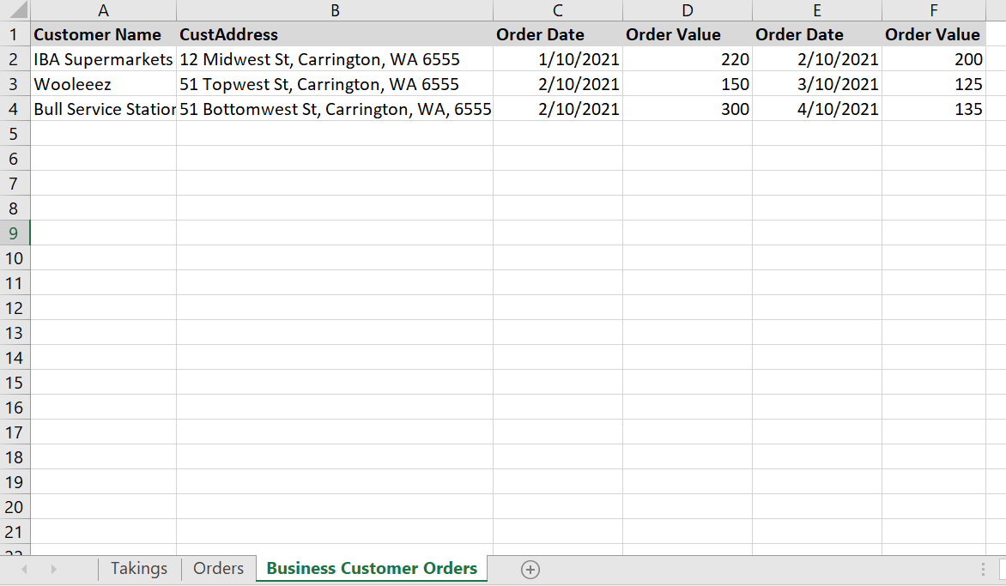

**Question 22 (12 marks)**

Refer to figures A and B on page 15 relate to Wesley’s spreadsheet.

1. Refer to Figure A and complete this table by identifying the formula contained in the cells listed. (8 marks)

|  |  |
| --- | --- |
| **Cell** | **Formula** |
| B6 |  |
| B7 |  |
| B8 |  |
| B9 |  |

1. Identify one advantage and one disadvantage associated with using a spreadsheet to store the business’s data. (2 marks)
2. As part of the System Development, Wesley is considering replacing his spreadsheets with a Relational Database Management System. Discuss the advantages and disadvantages of such a system. (2 marks)

**Question 23 (14 marks)**

1. At which stage of the System Development Life Cycle would a Context Diagram be drawn. (2 marks)

1. Using the information provided on the first page of the extended answer section   
   (page 14), create the Context Diagram below. (12 marks)

**Question 24 (28 marks)**

1. Create the Level 0 Data Flow Diagram below (23 marks)

The till is to be considered a store in this system.

1. What part of the Level 0 Data Flow Diagram is represented in an Entity Relationship Diagram? (1 mark)

1. Wesley is considering creating an order system for his larger business clients. This will require them to place a formal order and be invoiced once a month.

Describe how this change will impact both the Context Diagram and the Level 0 Data Flow Diagram. (4 marks)

**Question 25 (35 marks)**

Whilst the system was being designed, Wesley’s business customers began buying a lot of his bread and pastry/cake products. It has become clear a database is required.

The Analyst has observed the following.

* All his business customers can place many orders.
* An order will contain many products
* Each product has its own unique recipe
* A recipe contains many ingredients
* Each ingredient is supplied by only one supplier
* A supplier can supply several ingredients.

1. Create an Entity Relationship Diagram based on the above business rules below. (26 marks)

You will need to show all relationships, cardinality and develop sensible primary keys for each table.

1. The Analyst has suggested that the database become an online one. The business customers access a form within the database to place their orders by midday the day before they require their product. This would allow Wesley enough time to order the ingredients for baking the next morning.
2. Wesley’s recipes are a trade secret and he has raised concerns about the security of this data online. Discuss the security threats associated with putting this database online. (5 marks)

1. Identify and discuss two strategies Wesley could use to minimise the risk of his data being stolen. (4 marks)

**Question 26 (10 marks)**

In the lead up to Christmas, Wesley is running a promotion for his daily customers who buy coffees. They will receive a free coffee for every 9 that they purchase (so the 10th one free)

When his customers sign up for the promotion they will get a plastic identity card that they will present each time they purchase. Their card will be swiped on the till and updated with the coffee purchases they make. When the customer orders their 9th drink, there will be a prompt to advise the customer and the till operator that the next drink is free.

Write a program that will record the number of drinks bought and output “Next coffee free” after they have bought 9.

The Total variable must reset after the 10th coffee is served.

The first lines are written for you and you must use a loop.

**Program: Free_Coffee**

Var Total, CurrentPurch

Begin

Output(“How many drinks bought?”)

Read(CurrentPurch)

End of Examination Questions

Question No

Question No

Question No